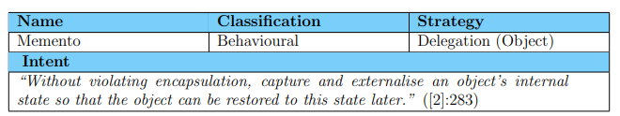**Memento**

* Snapshot
* Participants:
  + Originator
    - Wide interface
  + Memento
    - Narrow interface
  + Caretaker
* Keep info intact for later use
* Problem: originator object may be inadvertently exposed
* Related patterns:
  + Command
  + Iterator
  + Bridge

**example**

